**Termination rule:**

* There is a default termination rule policy.
* It will delete the instance with old launch configurations.

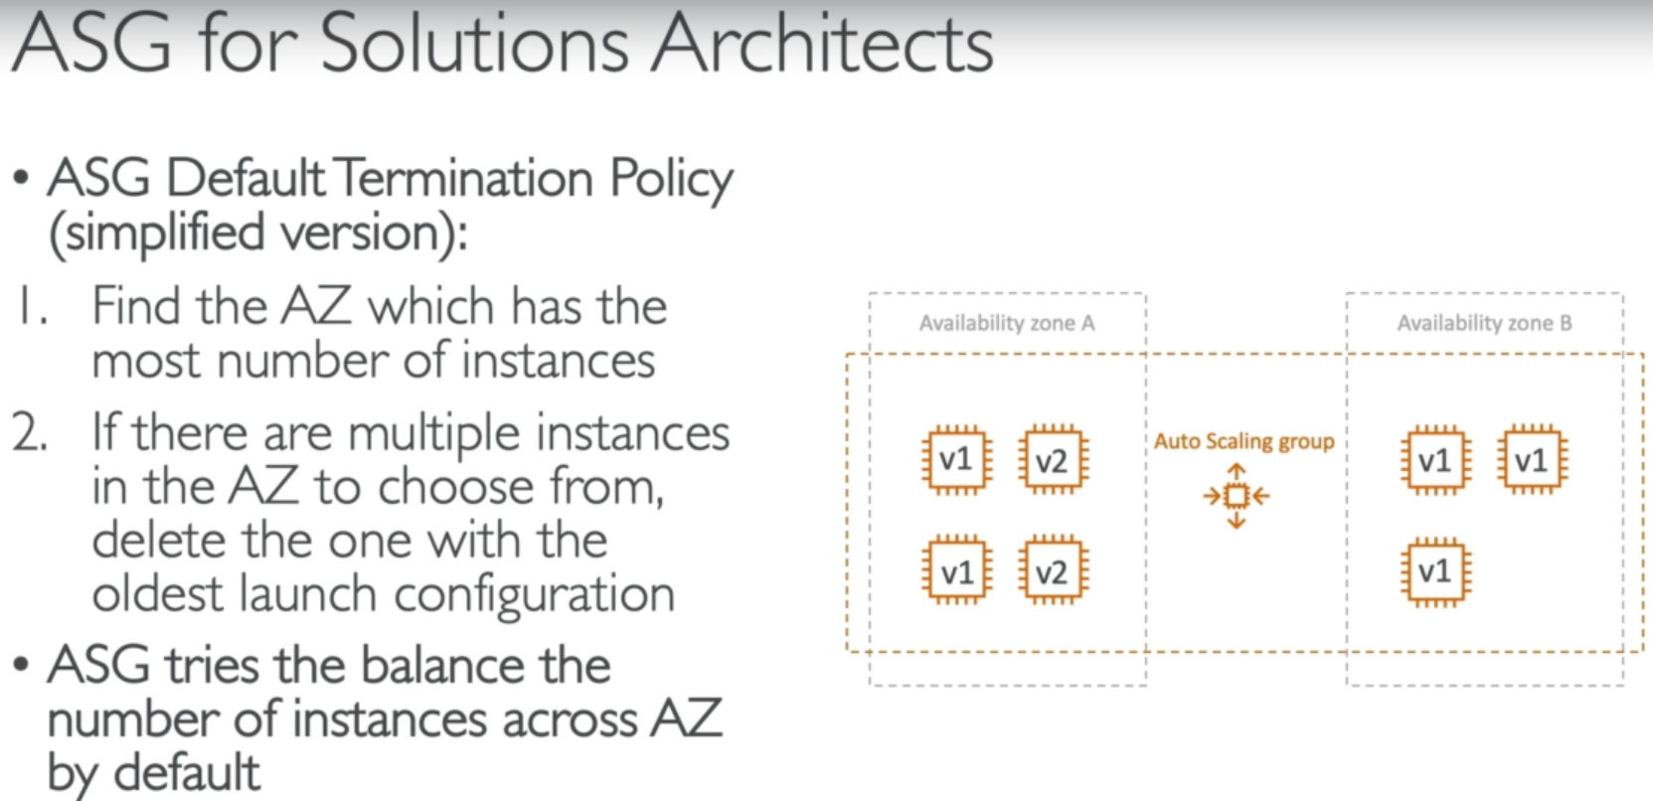

* As above, V1 is the old and v2 is latest
* And if ASG has to terminate an instance, it will be got for availability zone A as it has more instances than B
* And in A, it will choose v1 instance because it is old.

**Lifecycle hooks:**

* Below is the process when any instance gets created or terminated.

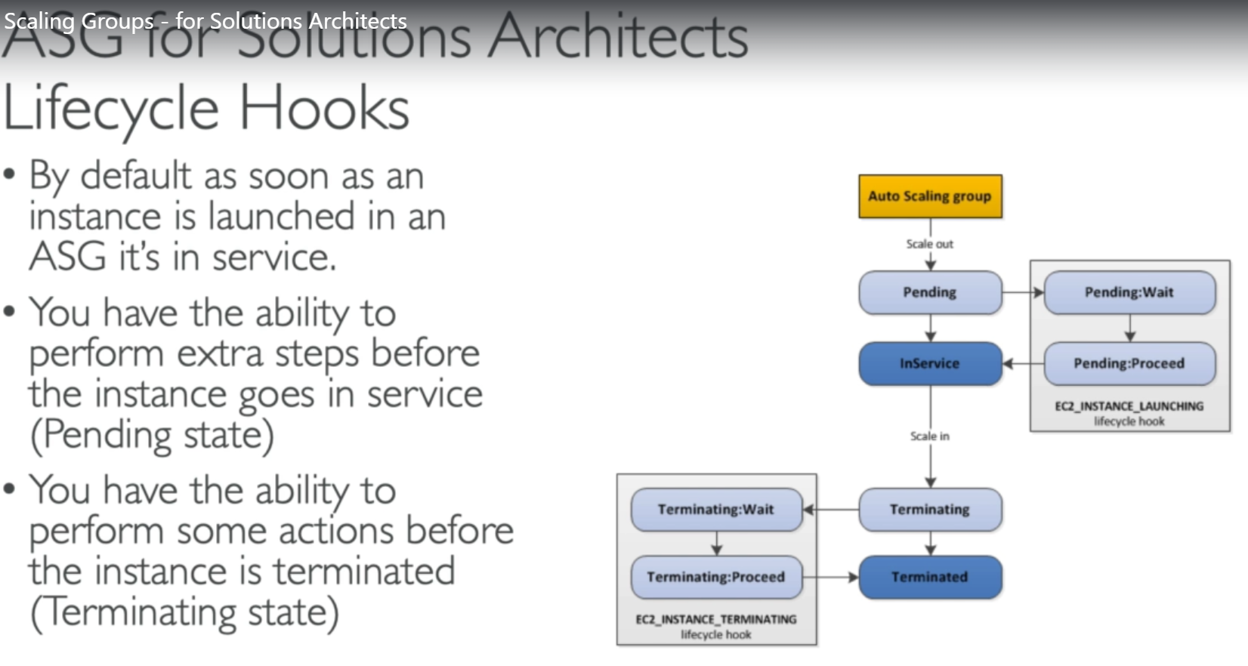

**Difference between launch template and launch configuration:**

* Launch configurations are old and everytime we need to recreate if for any changes.
* Launch template is new, and we can have version in this.

